→**Above code of feature Extraction :**

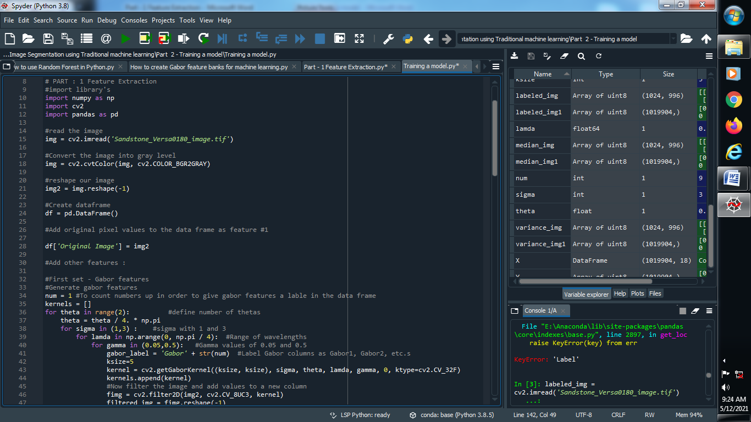

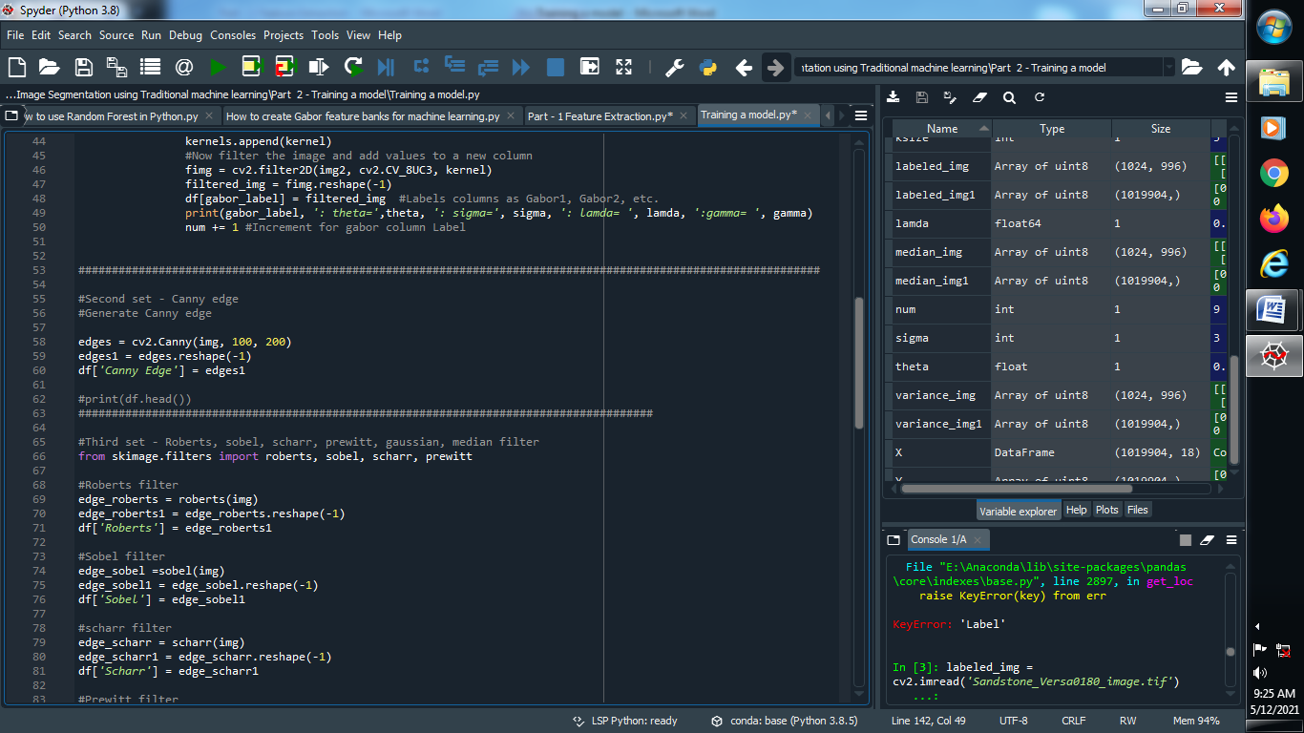

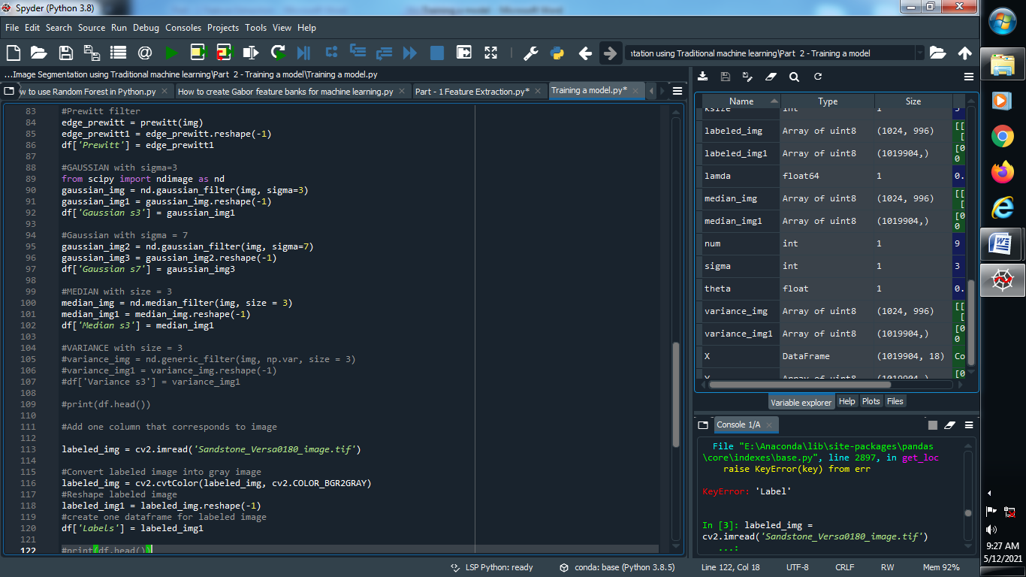

**→ Let’s Train our model :**

**(1) Define dependent and independent variables :**

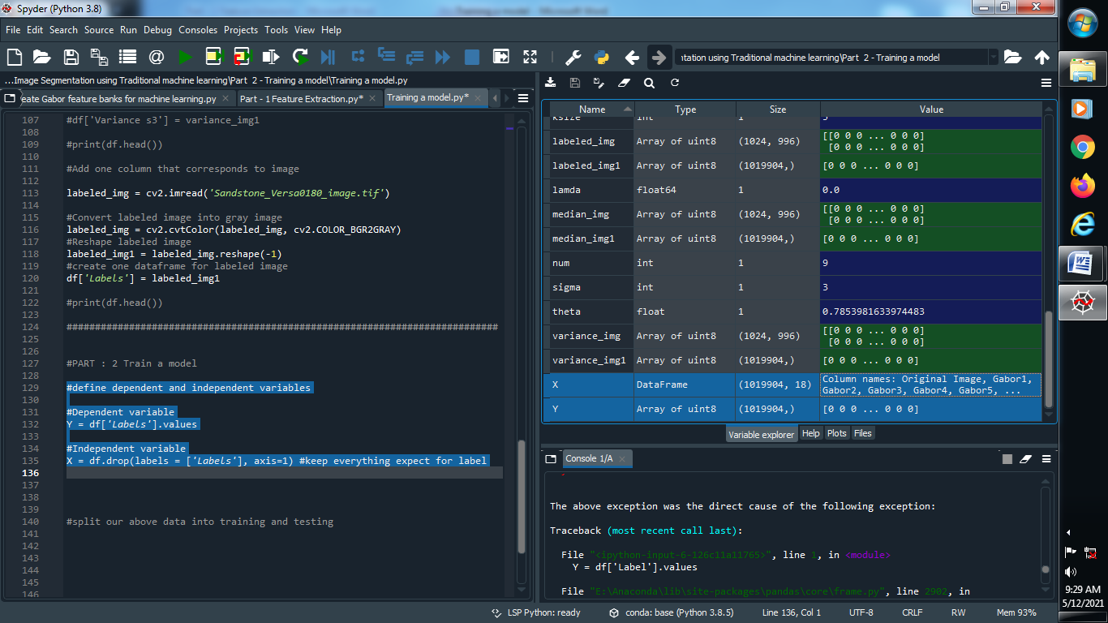

**Output :**



**(2) Split our data into training and testing :**

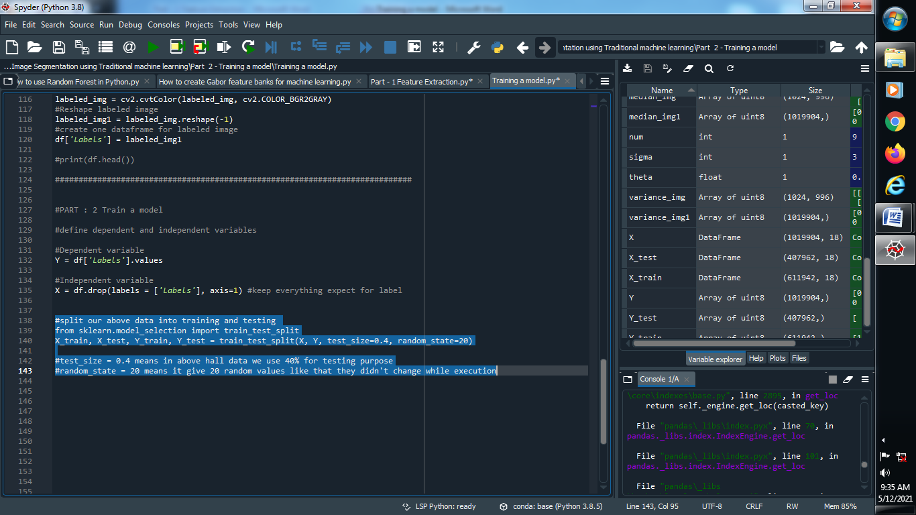

**Output :**

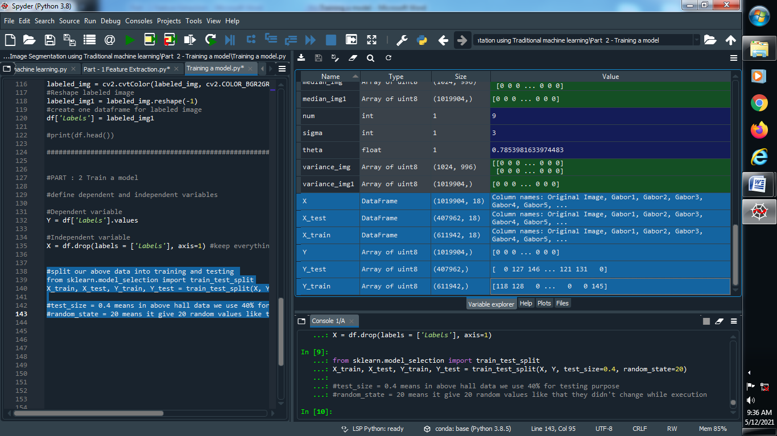

**(3) Apply Random Forest Classifier :**

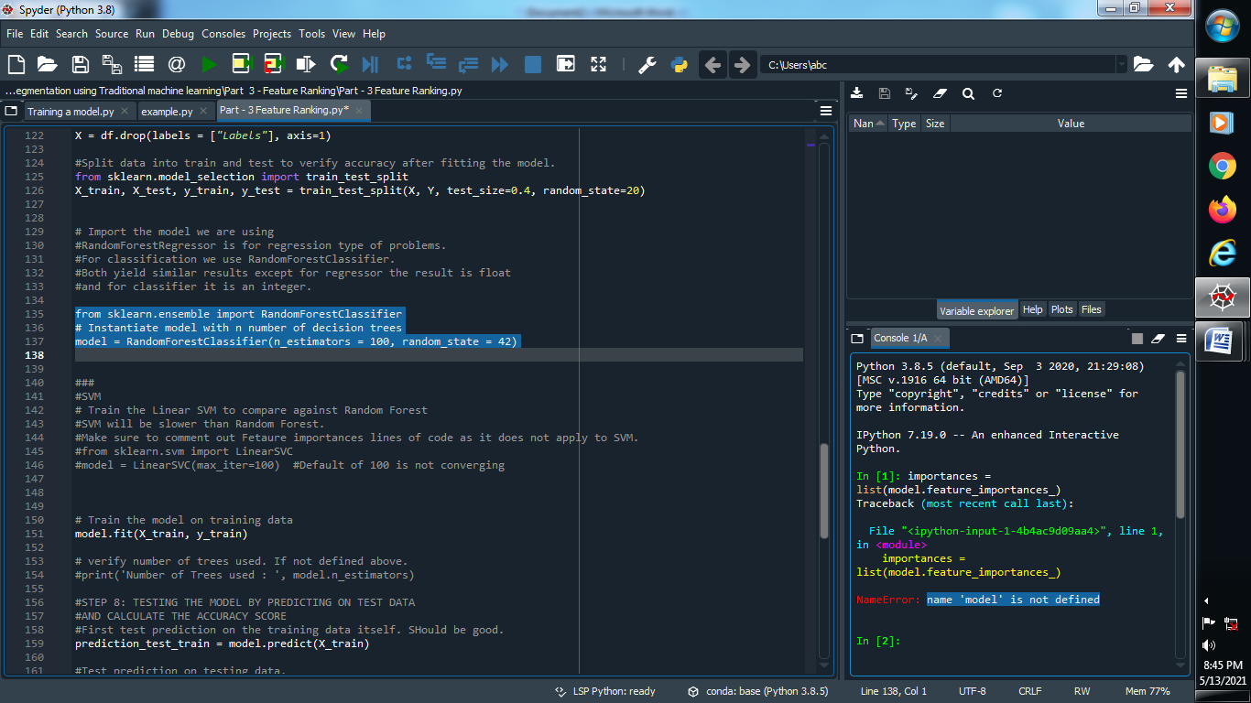

**(4) Fit Our model :**

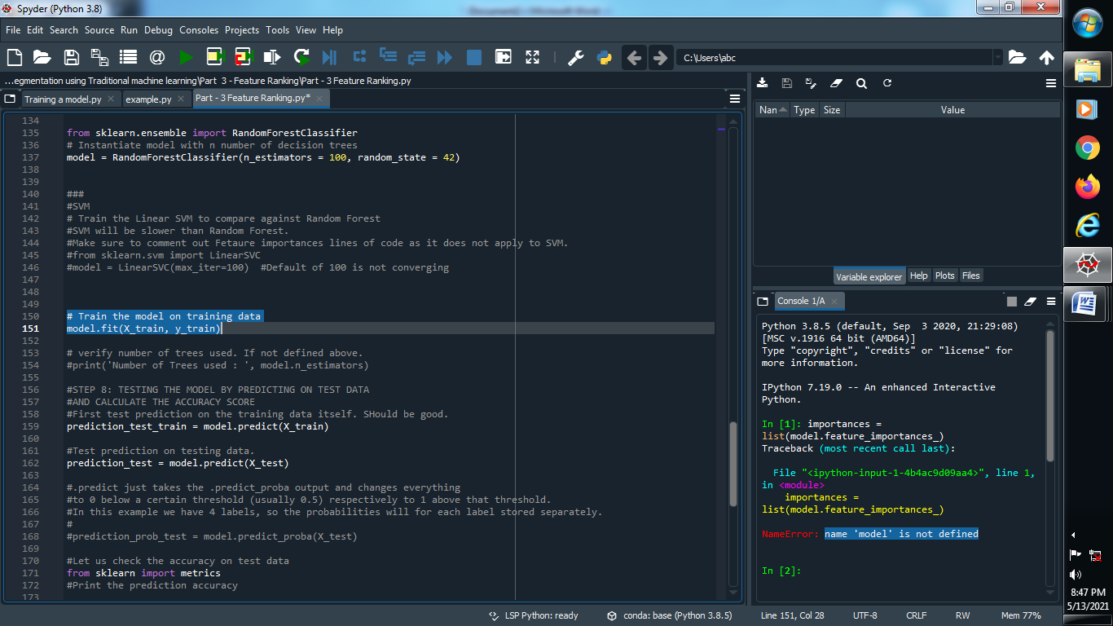

**(5) Predict Our training and testing dataset :**

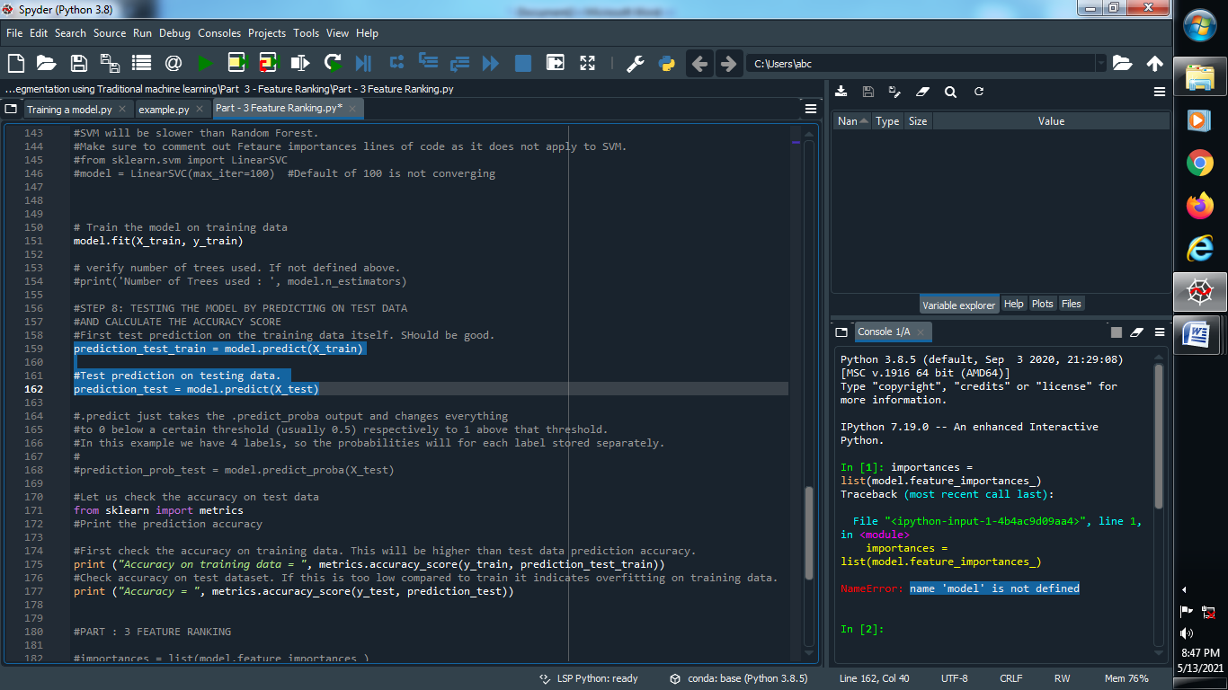

**(6) Find the accuracy of our predicted data :**

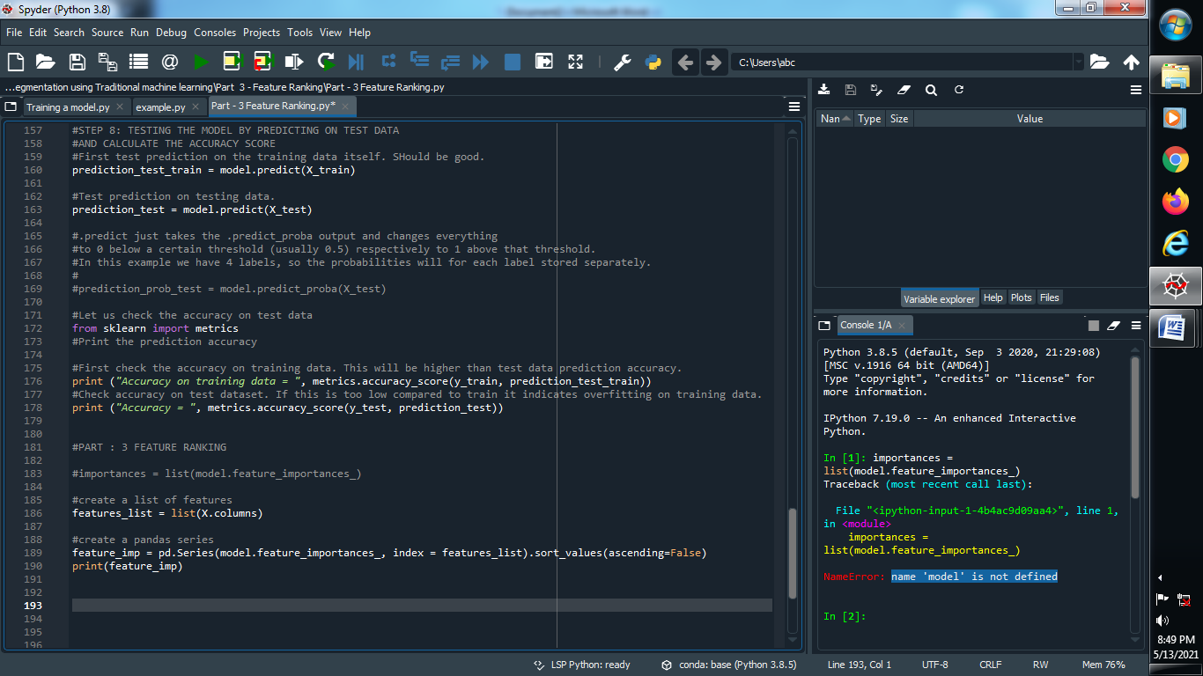

**Output :**

